**ECCS 1621 – Programming 2 – Spring Semester 2020**

**Term Project Team Building Assignment – Oregon Trail**

**Due by midnight Tuesday 30 March**

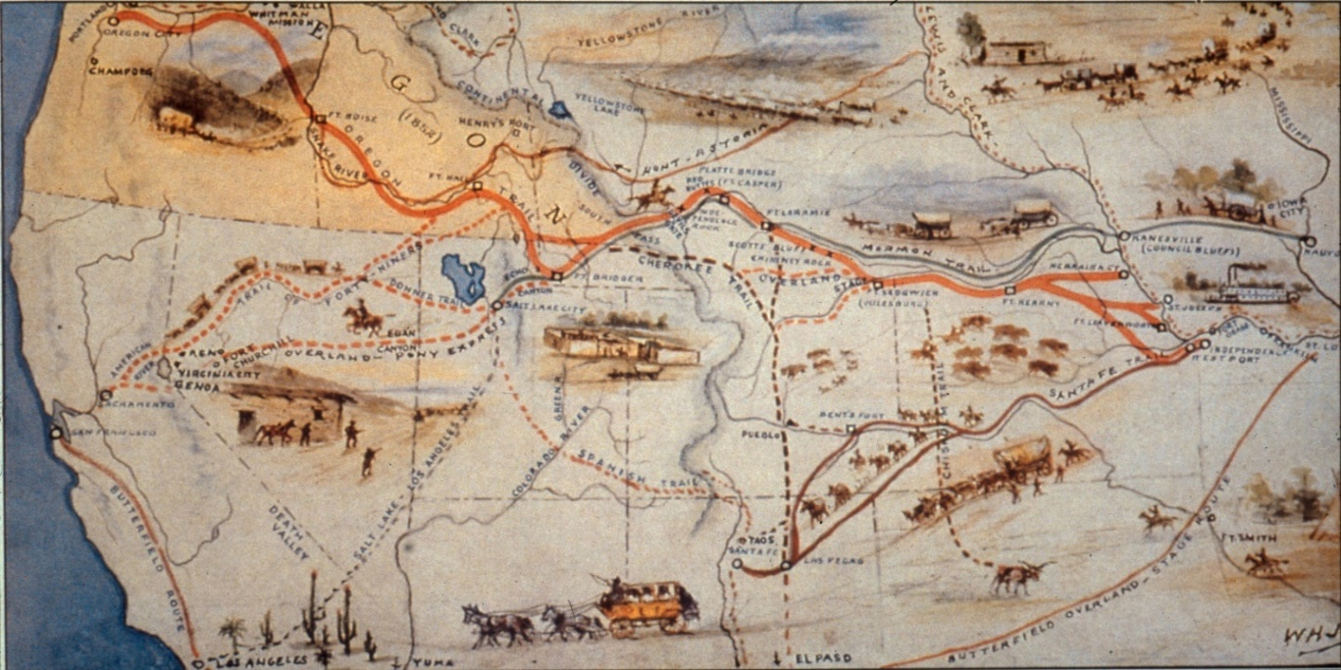

For this assignment, you and your team will be implementing an MVP (to be covered in-class) **text-based** version of an Oregon Trail simulation game, through use of the NABC Process (to be covered in-class). As part of this assignment, use the “thinking hats” development process to help jump-start the idea-development process (see handout on the NABC Method in Moodle for details). The Oregon Trail lesson plan has the following learning objectives:

Upon completion of this lesson, students will be able to:

* explain the significance of the Oregon Trail
* identify the path of the Oregon Trail
* describe the experiences of pioneers using the Oregon Trail

The scope of the project should be commensurate with the fact that you’re being given just a couple of weeks to write this (translated: don’t go overboard with “nice to have” items – focus on getting the overall program to work), and that you will need to demonstrate an MVP version of your program after one week to your client (i.e., instructor). With respect to the NABC Process, you must assume that the competition is the Wagons HO! Interactive Oregon Trail Experience (<https://www.blm.gov/or/oregontrail/files/wagons-ho.pdf>).

Our expectations are that teams **will** perform appropriate research for obtaining various elements of factual data (e.g., prices, distances), given the scope of the assignment.

**Please note that the goals for this assignment are to:**

1. **implement a working MVP application, and**
2. **develop a NABC pitch**

**for Oregon Trail: Teams are NOT performing a complete implementation.**

**Requirements:**

1. Make sure that an appropriate repository is used for working as a team on this project (GitHub + Google Drive). Please make sure that this is “shared” with your instructor.
2. Between now and **11:59 pm Sunday 21 March**, perform research on the Oregon Trail, using the references below plus additional references. All team members must individually research the competition’s web site and provide a 1/2-page (single spaced) synopsis that sufficiently describes that lesson. This synopsis is to be submitted via Moodle.
3. Each team must identify the need, approach, benefits, and competition (see The NABC Mindset handout in Moodle) for their Oregon Trail program. Each team needs to submit their NABC analysis by Moodle by **midnight Tuesday 23 March**. [Note: this and working on the CRC cards will be ‘lab’ for Tuesday]
4. Assume that the simulation you are writing is meant for sixth grade students, and that the simulation needs to be “do-able” within 30-45 minutes.
5. The CRC card process is to be used to start your class design process. Once classes are finalized, each class is to have a UML diagram created, and the public interface for each class is to be documented via Javadoc. To encourage this “Before Coding” approach to development, the deadline for completing your team’s CRC cards, UML diagrams, and Javadoc web site is **11:59 pm Friday March 26**. Submission for each document is to be one per team via Moodle.
6. As part of your development process, carefully consider what verbs need to be used within the code of your program – do not assume that you can just keep what’s already there,
7. You must create and appropriately use files for your data, that are then used to create appropriate instantiations of your classes.
8. The MVP version of your Oregon Trail program is to be implemented (i.e., up and running) by **11:59 pm on Tuesday, 30 March.** Each team will upload to Moodle (1) a 2- to 3-minute video presentation incorporating your NABC materials that includes a demo of your program, and (2) the Zip file (or link to your github / google drive) for instructor to execute. Please note that this is a firm deadline.

**ADDITIONAL REFERENCES:**

* <https://archive.org/details/msdos_Oregon_Trail_The_1990> - 1990 MS-DOS version of Oregon Trail, playable online via the Internet Archive. This is a fun way to research this project and obtain useful data (prices, distances, etc.). Please note that you are NOT being asked to recreate this program!
* <http://www.legendsofamerica.com/we-oregontrail.html> - Background information for the Oregon Trail, including links to eyewitness accounts and historic sites.
* <http://www.history.com/news/history-lists/9-things-you-may-not-know-about-the-oregon-trail> - Some facts that you might not have been aware of concerning the Oregon Trail.
* <https://edsitement.neh.gov/node/7576> - “Go West: Imagining the Oregon Trail” lesson plan.
* <https://www.blm.gov/or/oregontrail/files/packwagon.pdf> - “Pack Your Wagon” lesson plan materials.
* <https://psolarz.weebly.com/westward-expansion/oregon-trail-simulation-lesson-guide> - Blog created by students studying Westward Expansion.
* <https://www.oregontrailcenter.org/index.html>
* <https://www.historicoregoncity.org/2016/11/23/doctors-and-diseases-on-the-oregon-trail/>
* <https://www.wyohistory.org/encyclopedia/crossing-north-platte-river>
* <https://brianaltonenmph.com/6-history-of-medicine-and-pharmacy/oregon-trail-1837-1857/cholera-on-the-oregon-trail-thesis/>
* <https://www.wyohistory.org/encyclopedia/trails-across-wyoming-oregon-mormon-pioneer-and-california-routes>